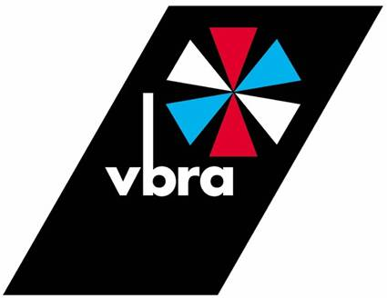Technical Bulletin No.25
September 2015
Welding Fumes – Safety Alert (Revision 1 – 2013)
(Courtesy of British Compressed Gases Association)
TIS 24 (Technical Information Sheet)
The publishing of guidelines for safe working and health & safety when carrying out all forms of welding are constantly under review, a report is imminent from the HSE regarding this subject, it will no doubt confirm what is already known.
This technical information bulletin from the BCGA is very relevant, and it is a timely reminder that employers should already be taking steps to protect their employees from risk.
Please use this document as guidance.

Any questions please contact;
Gerry Braddock, Project Manager, VBRA
07776-294744, email; gerryb@vbra.co.uk

Vehicle Builders and Repairers Association
1 Howley Park, Pullan Way, Morley, Leeds, LS27 0BZ
Tel 0113 253 8333 www.vbra.co.uk

BRITISH COMPRESSED GASES ASSOCIATION
Registered office: 4a Mallard Way, Pride Park, Derby, DE24 8GX
Company Number: 71798, England
www.bcga.co.uk

TECHNICAL INFORMATION SHEET 24
Revision 1: 2013
WELDING FUMES – SAFETY ALERT
- SCOPE
Metal welding, both arc and gas, and cutting produces a variety of hazards, not only to those directly involved but also in the surrounding area. Obvious dangers exist such as a fire hazard; the handling of compressed, fuel and shielding gases; solvents and material handling. However a significant hazard exists from fumes. This publication aims to highlight the potentially fatal consequences in both the short and long term that these can present.
- OVERVIEW OF FUMES
The content of fumes may be either asphyxiating or toxic.
Asphyxiating fumes are mainly due to shielding gases and produce their effect by displacing oxygen from the surrounding air, excessive quantities can cause suffocation. They are most commonly argon (Ar), helium (He) and nitrogen (N2). This risk is well documented and is covered in BCGA Guidance Note 11.
Toxic fumes can be both gaseous and particulate. These fumes can present a serious threat to health and ultimately life in both the short and long term.
Short-term risks:
- Eye irritation.
- Shortness of breath, and irritation to respiratory tract.
- Metal fume fever.
- Poisoning by many metals e.g. zinc, barium, manganese, nickel, lead, copper, chromium, cadmium and aluminium. Fume containing these metals is toxic and can cause immediate risk of injury.
- Ozone, carbon monoxide and oxides of nitrogen are formed in some welding and cutting processes. These cannot be detected by the senses, but are toxic.
NOTE: Short-term risks like these are fairly well known and understood, but failure to take
appropriate precautions will still expose workers to risk of injury or even death.
Long-term risks:
There is an increasing understanding that exposure to fume can lead to serious chronic health problems in the long term, perhaps many years later. Smoking is now well-known to cause serious health problems in later life and exposure to fume must be treated as a similar risk. The risks include:
- Chronic Obstructive Pulmonary Disease (COPD). This is caused by many factors, such as exposure to dust, and is now linked to exposure to welding fume.
- Lung cancer. This can be caused by exposure to many substances, including heavy metal fume.
NOTE: The Health and Safety Executive (HSE) have estimated 12,000 people die in the UK each year from long latency health issues, i.e. disease caused over a long period. Of these approximately 4,000 are caused by lung disease with 3,000 attributed to COPD. Many of these will have been at least partly caused by occupational exposure.
BCGA has engaged with the HSE and others via the Welding Fume Team to try to influence attitudes and behaviours with respect to welding fume, particularly in encouraging the use of appropriate Personal Protective Equipment. The Welding Fume Team has produced a website www.badairday.info which explains in detail the safety concerns associated with welding fume and which encourages appropriate safe behaviour. | 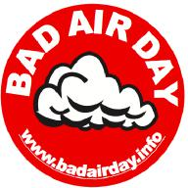

3. WHAT DOES THE LAW SAY, AND HOW SHOULD STAFF BE PROTECTED?
The Health & Safety at Work etc. Act places general duties on employers and employees.
Employers, including self-employed persons, must ensure the health and safety of their employees so far as is reasonably practicable. To do this they must:
- Conduct a risk assessment of all activities which involve a risk to health and safety. This must be formally recorded.
- Make available to employees information about the risks identified and the control measures put in place to mitigate them.
- Provide protective equipment as necessary.
- Provide training to employees on procedures and safety.
Employees must cooperate with their employer in relation to health and safety issues. This requires that they:
- Follow instructions for safe working.
- Participate in training.
- Use the protective equipment provided.
It is vital that employers and employees recognise these duties, which are enshrined in criminal law.
3 of 4

Protection of staff may require the use of:
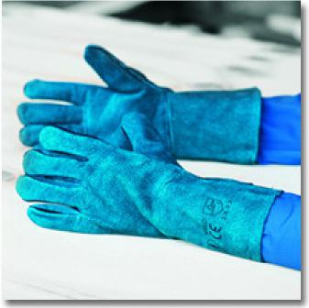 | 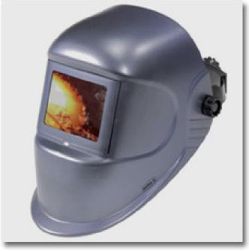
Heat resistant gloves, safety boots,  fire-resistant clothing | Eye protection, often with full face visor
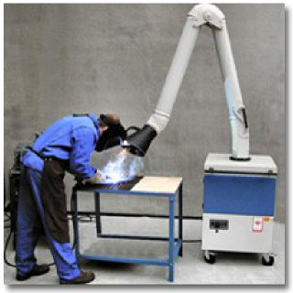 | 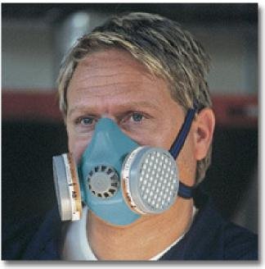
Extraction / ventilation system to  ensure clean air supply | Breathing apparatus or respirator

The actual requirement for any job will be defined in the overall risk assessment. Employees must ensure that they follow the instructions to use the protection systems provided.
If you have any enquiries on this subject please contact Gerry Braddock (see covering page), your VBRA Area Manager or VBRA Head Office (013 253 8333)

