Technical Bulletin No.26
September 2015
Gas Equipment Inspection/Replacement Date Marking
Revision 2-2013
(Courtesy of British Compressed Gases Association)
TIS 18 (Technical Information Sheet)
The publishing of guidelines for checking and assessing the replacement date of compressed gas equipment such as regulators, flashback arrestors, safety valves and high pressure hoses has been available for some time, but there has been some confusion.
This technical information bulletin from the BCGA clarifies the markings and dates that you need to be aware of when inspecting and replacing the various date stamped components. It is a timely reminder that employers should already be taking steps to protect their employees from risk.
Please use this document as guidance, this requirement has been around for some time and will become the subject of any audit in the future.
Any questions please contact;
Gerry Braddock, Project Manager, VBRA
07776-294744, email; gerryb@vbra.co.uk
BRITISH COMPRESSED GASES ASSOCIATION
Registered office: 4a Mallard Way, Pride Park,
Derby, UK, DE24 8GX
Company Number: 71798, England
Technical Information Sheet 18
Revision 2: 2013
Gas Equipment Inspection / Replacement Date Marking
Objective
Members have expressed a view that some manufacturers and suppliers use various systems of date marking or inspection / replacement stamps to identify the age of industrial gas equipment. This causes confusion sometimes making it difficult to establish the age of equipment, which is required to be known to comply with various British Compressed Gases Association (BCGA) Codes for maintenance recommendations. BCGA Code of Practice 7 provides guidance on the maintenance requirements and the periodicity between maintenance for industrial gas equipment.
Scope
Industrial pressure regulators, flashback arrestors, pipeline safety relief valves and high pressure flexible hoses attached to mobile systems or manifolds.
Terminology
Pressure regulator.
Fitted to the outlet of the gas cylinder valve or manifold, the pressure regulator reduces the pressure of the gas from the cylinder pressure to the lower pressure required for the operation of the process equipment.
Flashback arrestor.
A device which arrests a flame front (caused by flashback or decomposition) and which is suitable for the most severe type of flame which may occur, i.e. detonation.
High-pressure flexible hose.
A flexible connection between the cylinder valve and manifold header.
Date Codes
The following pages show for each of the main BCGA member companies who supply such equipment how their system for date coding operates.
1 of 17
1. Gas Control Equipment Ltd.
For further information: www.gcegroup.com

Regulators | 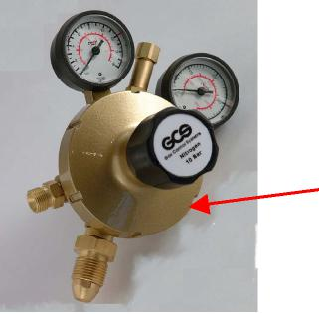 | Marking on rear face (see Figure 1.3)

Figure 1.1: Series 300 Multi-Stage Regulators

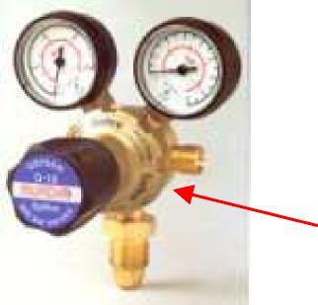 | Marking on rear face (see Figure 1.3)

Figure 1.2: Series 300 Multi-Stage Regulators
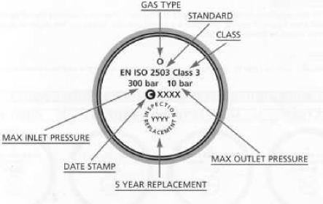 | See also  Table 1.1

Figure 1.3: Example of marking on the rear face of a regulator
2 of 17
BCGA TIS 18 – Revision 2
Published: 09/05/2013 Produced by: BCGA TSC 3

Flashback Arrestors

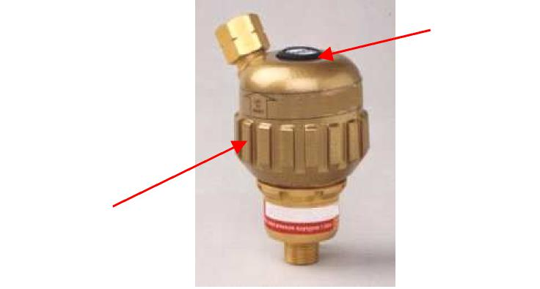
Date Code (see Table 1.2)
Replacement Date

Figure 1.4: Resettable 36ec Flashback Arrestors

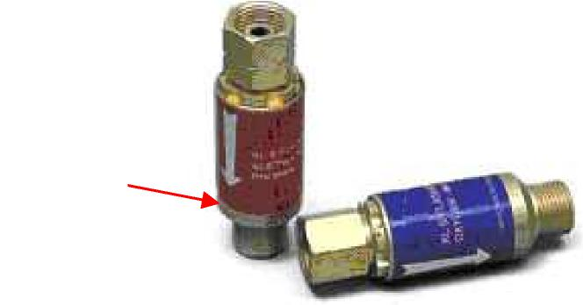
Date Code (see Table 1.2)

Figure 1.5: Barrel XL5 Flashback Arrestors

Table 1.1 provides a marking format for regulators.
Decade: | C = 1990  D = 2000  E = 2010 etc.
Year: | 0 = 0  1 = 1  2 = 2  3 = 3  4 = 4 | 5 = 5  6 = 6  7 = 7  8 = 8  9 = 9
Month: | A = January  B = February  C = March  D = April  E = May  F = June | G – July  H = August  I = September  J = October  K = November  L = December
Manufacturing site: | S = Skelmersdale A or F = Another | / Stone Cross

Table 1.1: GCE marking format for regulators
An example of the date coding system is as follows:
“D7FS” = Skelmersdale / Stone Cross origin made in June 2007.
Table 1.2 provides a marking format for some flash back arrestors. A single digit code represents the year of manufacture.
Table 1.2: GCE marking format for flash back arrestors

Year:
C = 1999 K = 2007
D = 2000 L = 2008
E = 2001 M = 2009
F = 2002 N = 2010
G = 2003 O = 2011
H = 2004 P = 2012
I = 2005 Q = 2013
J = 2006
4 of 17
BCGA TIS 18 – Revision 2
Published: 09/05/2013 Produced by: BCGA TSC 3
2. Gas-Arc Group Ltd
For further information: www.gas-arc.co.uk

Regulators
Single-Stage Regulator
Inspection/Replacement date is marked on the side of the regulator body, next to the inlet connection as shown in Figure 2.1.
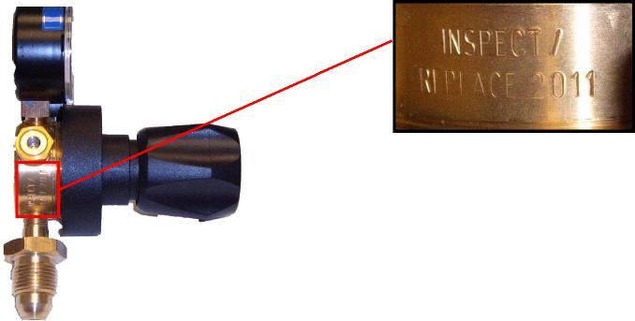
Figure 2.1: Single-Stage Regulator
The mark in Figure 2.1 identifies that the product is due for replacement by 31st December 2011.
Multi-Stage Regulator
Inspection/Replacement date is marked on the side of the regulator body, next to the inlet connection as shown in Figure 2.2.
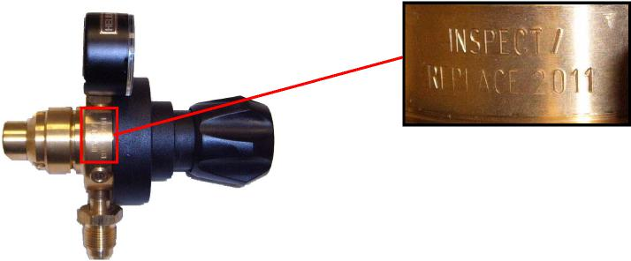
Figure 2.2: Multi-Stage Regulator
5 of 17

The mark in Figure 2.2 identifies that the product is due for replacement by 31st December 2011.
Flashback Arrestors
Model GA-D99 Flashback Arrestor
All Gas-Arc Flashback Arrestors are marked with the date of manufacture shown as month and year. The example in Figure 2.3 is marked “07 06” and would have been manufactured in July 2006.
Figure 2.3: Model GA-D99 Flashback Arrestor
This product would be due for replacement five years from the end of the year of manufacture i.e. 31st December 2011.
Model GA-D97 Flashback Arrestor
All Gas-Arc Flashback Arrestors are marked with the date of manufacture shown as month and year. The example in Figure 2.4 is marked “07 06” and would have been manufactured in July 2006.
Figure 2.4: Model GA-D97 Flashback Arrestor
This product would be due for replacement five years from the end of the year of manufacture i.e. 31st December 2011.
6 of 17
High Pressure Flexible Hose
Gas-Arc High Pressure Flexible Hoses are marked with their recommended replacement date, shown below as 10/2011 in Figure 2.5.
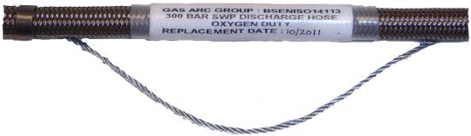
Figure 2.5: High Pressure Flexible Hose This hose would be due for replacement on 30th October 2011.

3. BOC Gases
For further information: www.boconline.co.uk

Regulators
All BOC UK regulators are stamped with the recommended year of replacement, which is approximately six years after the year of manufacture. BOC Series 8500 laboratory regulators are stamped around the sand-blasted body of the regulator. Other BOC Series regulators will be stamped on the flat, sand-blasted body back as shown in Figure 3.1.
Figure 3.1: BOC Regulator Stampmarking Flashback Arrestors
All BOC flashback arrestors are stamped with a two letter code showing the month and year in which they were manufactured. See Table 3.1.
The BOC Standard and Premier Flashback arrestors carry the two letters below the BOC label, on the main body of the unit. On the BOC Resettable, the letters are found on the smooth portion below the ridges around the main body.
As an example, a flashback arrestor marked A3 would have been manufactured in January 2013.
Month: | A = January  B = February E = March | G = April  K = May  N = June | P = July  S = August  T = September | V = October  X = November  Z = December
Year: | A = 1990 | K = 1998 | V = 2006 | 4 = 2014
 | B = 1991 | L = 1999 | W = 2007 | 5 = 2015
 | C = 1992 | M = 2000 | X = 2008 | 6 = 2016
 | D = 1992 | N = 2001 | Z = 2009 | 7 = 2017
 | E = 1994 | P = 2002 | 0 = 2010 | 8 = 2018
 | H = 1995 | S = 2003 | 1 = 2011 | 9 = 2019
 | I = 1996 | T = 2004 | 2 = 2012
 | J = 1997 | U = 2005 | 3 = 2013

Table 3.1: BOC marking format for flashback arrestors
Nexus  Regulators  The Nexus range of regulators will be stamped as shown in Figure 3.2 and the making format is shown in Table 3.2.  As an example, a regulator marked FG would have been manufactured in July 2013. | 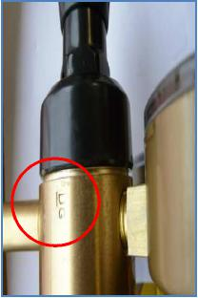
 | Figure 3.2: Nexus Regulators

Flashback Arrestors
The Nexus range of flashback arrestors are marked in accordance with Table 3.3 and as illustrated in Figure 3.3. They have a serial number above the flow direction arrow with a three digit date code below. As an example, a flashback arrestor marked E3C = 2013 March. The product label in Figure 3.3 is provided with a section for marking the last inspection date (year/ month).
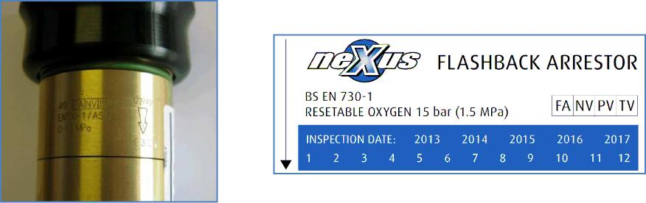

Figure 3.3: Nexus flashback arrestors marking scheme
Blowpipes  The Nexus range of blowpipes will be stamped as shown in Figure 3.4 and the making format is shown in Table 3.2 | 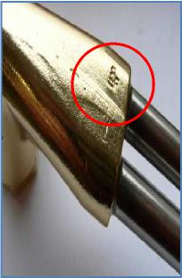
 | Figure 3.4: Nexus Cutting Blowpipes

Month: | A = January | G = July
 | B = February | H = August
 | C = March | J = September
 | D = April | K = October
 | E = May | L = November
 | F = June | M = December
Year: | F = 2013 | M = 2019
 | G = 2014 | N = 2020
 | H = 2015 | P = 2021
 | J = 2016 | Q = 2022
 | K = 2017 | R = 2023
 | L = 2018 | S = 2024

Table 3.2: Nexus marking format for regulators and cutting blowpipes.
Month: | A = January | G = July
 | B = February | H = August
 | C = March | J = September
 | D = April | K = October
 | E = May | L = November
 | F = June | M = December
Year: | E3 = 2013 | E9 = 2019
 | E4 = 2014 | F0 = 2020
 | E5 = 2015 | F1 = 2021
 | E6 = 2016 | F2 = 2022
 | E7 = 2017 | F3 = 2023
 | E8 = 2018 | F4 = 2024

Table 3.3: Nexus marking format for flashback arrestors

RYVAL
Regulators
The RYVAL range of regulators will be stamped as shown in Figure 3.5. The date shown is the year by which they are to be replaced.
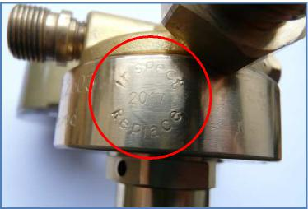
Figure 3.5: RYVAL Regulators
Flashback Arrestors
The RYVAL range of flashback arrestors are marked in accordance with Figure 3.6. These flashback arrestors are marked with the year of manufacture.
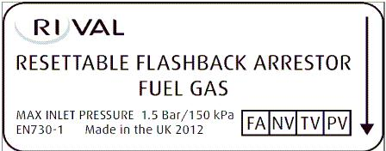
Figure 3.6: RYVAL flashback arrestors marking scheme
Blowpipes
The RYVAL range of blowpipes will be stamped as shown in Figure 3.7. These blowpipes are marked with the year of manufacture.
On the example shown “1010” - this is week 10 of 2010.
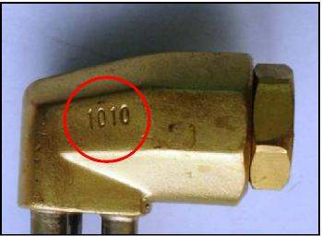
Figure 3.7: RYVAL Cutting Blowpipes
High pressure flexible hose assemblies
4. Aeroflex Hose & Eng Ltd
For further information: www. aeroflex.co.uk

Typical data on coloured sleeving. Individual customers specify their marking requirements; however, where possible the following data is used:
- Design pressure.
- Nominal bore.
- Nominal length.
- Test date.
- Test pressure.
- Batch number.
- When allowed the Aeroflex name or initials.
- Any relevant specification and the gas duty.
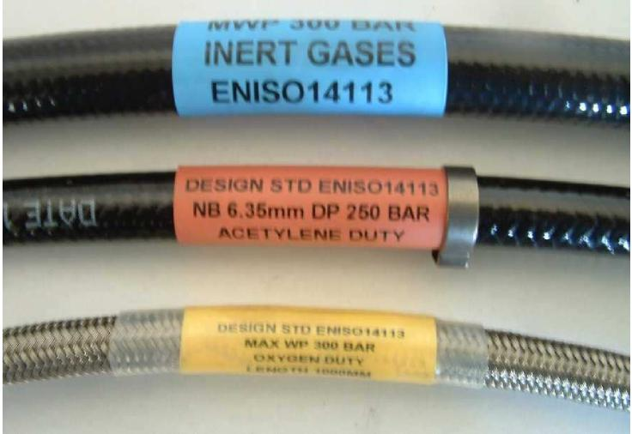
Figure 4.1: Aeroflex hose identification – Sleeve
The colour selection unfortunately differs from customer to customer; but wherever possible yellow is used for oxygen and unlimited shelf life and blue is used for inert gases.

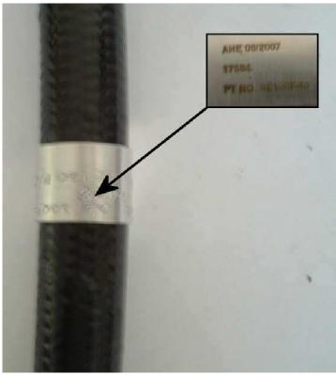 | 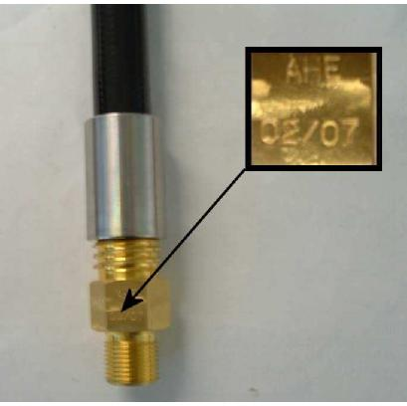
Figure 4.2: Aeroflex hose  identification – Metal tag | Figure 4.3: Aeroflex hose identification – Hard stamped

Figure 4.2 is an example of a metal tag used where a coloured polyoflin sleeve cannot be used such as cryogenics etc. (Variable data, but always AHE (Aeroflex Hose & Eng Ltd.), batch number and date).
Additionally, as well as coloured sleeving and metal tagging the product will be hard stamped (Figure 4.3) or roll marked or etched (Figure 4.4) with the following data: AHE, Batch No. and Month & Year.
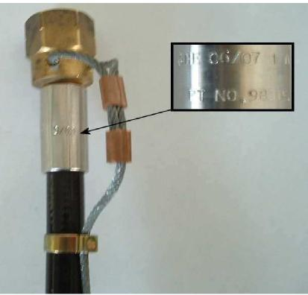
Figure 4.4: Aeroflex hose identification – Roll marked or etched

5. Black Teknigas Ltd.
For further information: www.blackteknigas.com

Regulators
Tekniflo Autochange Regulator
Replacement date is marked on the top of the regulator body, next to outlet connection, where shown in Figure 5.1.
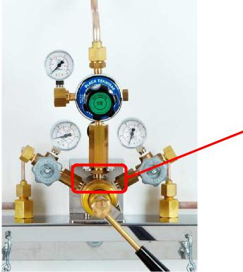
Replacement date

Figure 5.1: Tekniflo Autochange Regulator
Multi-Stage Regulator
Replacement date is marked on the side of the regulator body, where shown in Figure 5.2.

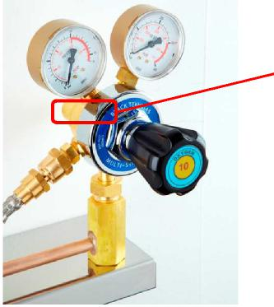
Replacement date

Figure 5.2: Multi-Stage Regulator

Single-Stage Regulator
Replacement date is marked on the side of the regulator body, where shown in Figure 5.3.
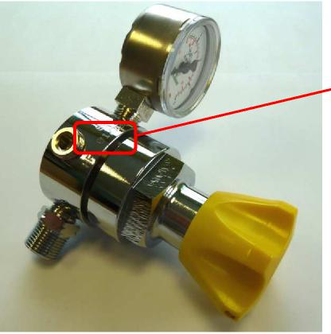
Replacement date

Figure 5.3: Single-Stage Regulator
Flashback Arrestor
Model DGN MC00197 Flashback Arrestor
Black Teknigas Ltd Flashback Arrestors are marked with the year of manufacture, where shown in Figure 5.4. The product would be due for replacement five years from the end of the year of manufacture.

Figure 5.4: Model DGN MC00197 Flashback Arrestor
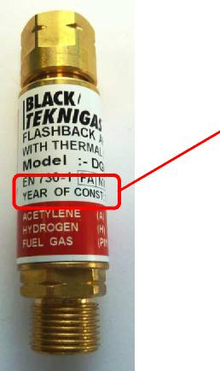
Year of manufacture

6. Air Liquide Welding Ltd.
For further information:http://www.airliquidewelding.com

Regulators
Figure 6.1 showing the stamping on a regulator, indicating the month and year of manufacture.
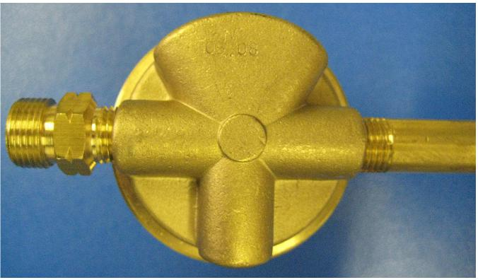
Figure 6.1: Air Liquide Regulator Marking
Figure 6.2 provides a close-up view of the stamping on a regulator, showing month and year of manufacture
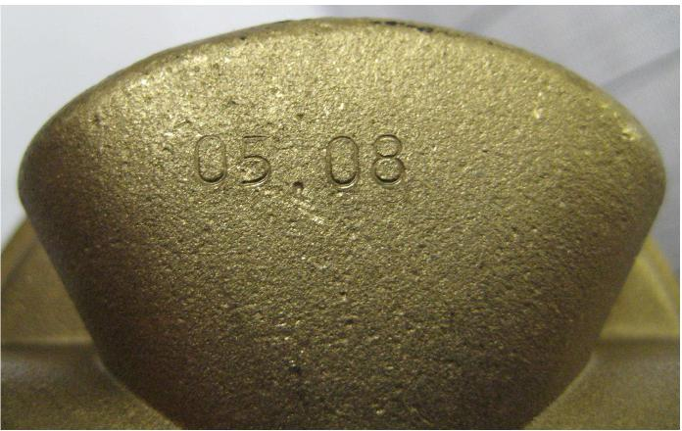
Figure 6.2: Air Liquide Regulator Marking – Close-up

Flashback Arrestors
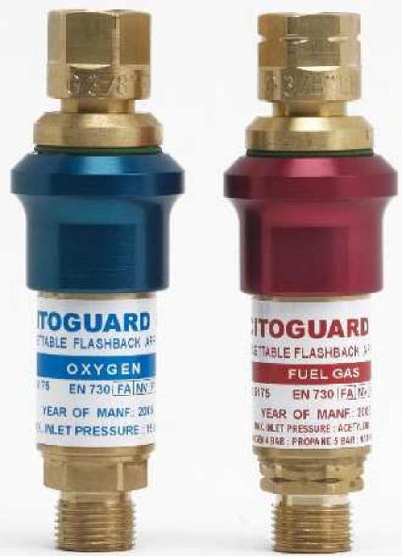
Figure 6.3: Air Liquide Flashback Arrestor Marking
Citoguard R5 resettable flashback arrestors, showing year of manufacture marking.
For more information: speak with Gerry Braddock (see covering page) or your VBRA Area Manger.
The formatting of the original has been altered by VBRA for expediency but the content has not. This document is for guidance only. The only controlled copy of this paper is held by the British Compressed Gases Association

